**Advantages of Storing State in the URL**

* Global Accessibility: State stored in the URL can be accessed by any component in the application without needing to pass it down through props.
* Ease of Data Transfer: State in the URL allows easy transfer of data from one page to another without temporary storage.
* Shareable and Bookmarkable UI State: URLs with state enable users to share or bookmark a page with a specific UI state, providing a consistent user experience.

**Types of URL State Management**

* Path Parameters: Used to pass data to specific components or pages (e.g., /app/cities/Lisbon).
* Query Strings: Useful for storing global state that should be accessible across the application (e.g., ?lat=38.716&lng=-9.139).

**Examples**

* Path Parameters: Using a city name in the URL to load the corresponding city's page.
* Query Strings: Storing latitude and longitude in the URL to reflect a map's position.

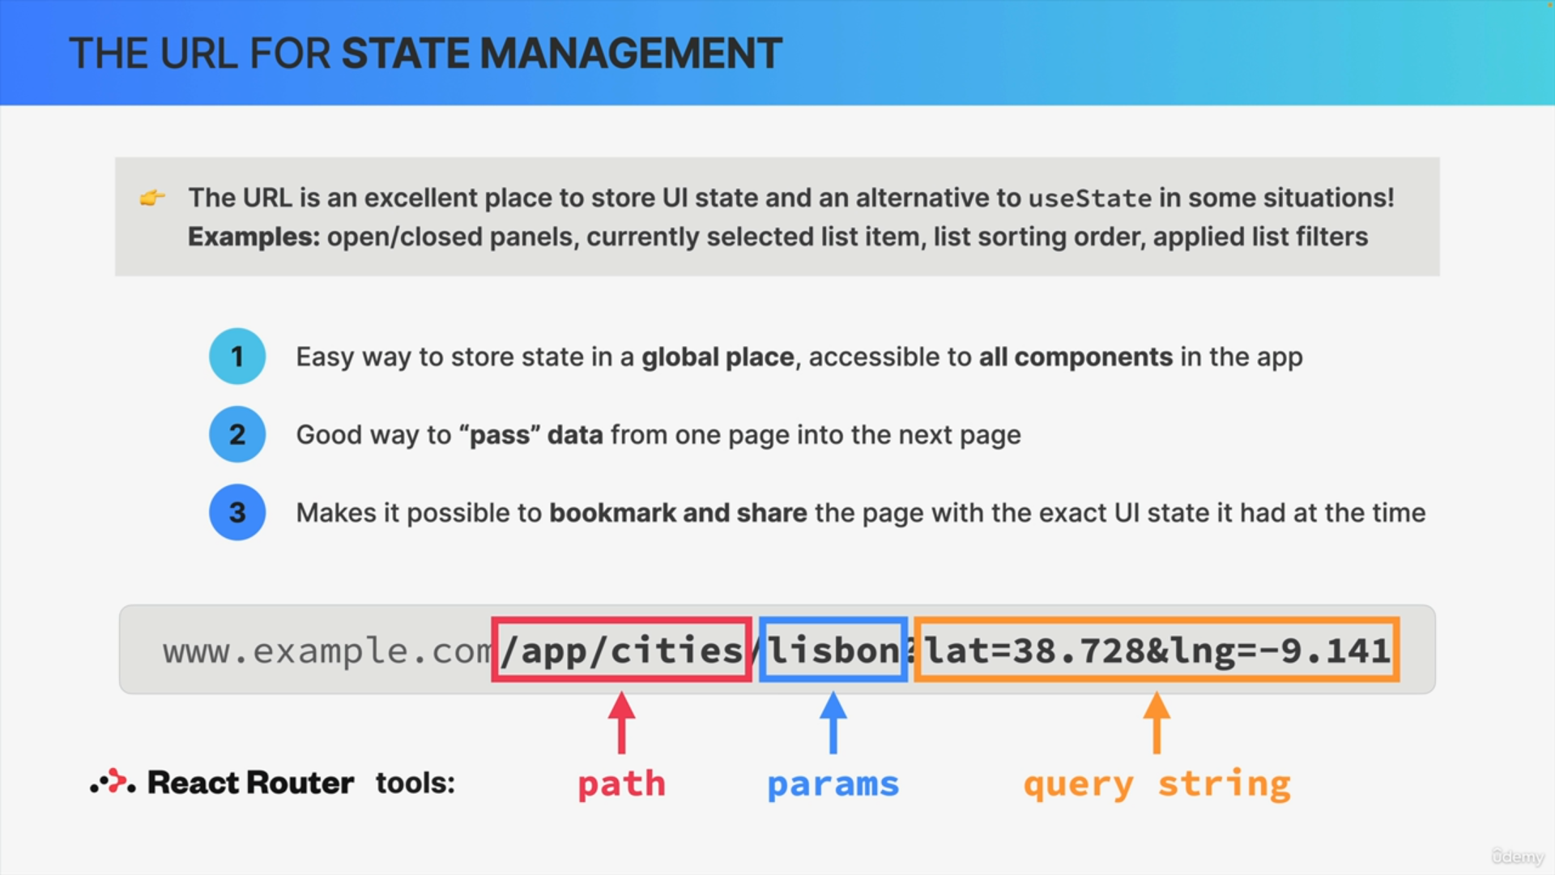

**Practical Application**

* By using path parameters and query strings, state management can be shifted from React components to the URL, making it more efficient and user-friendly.

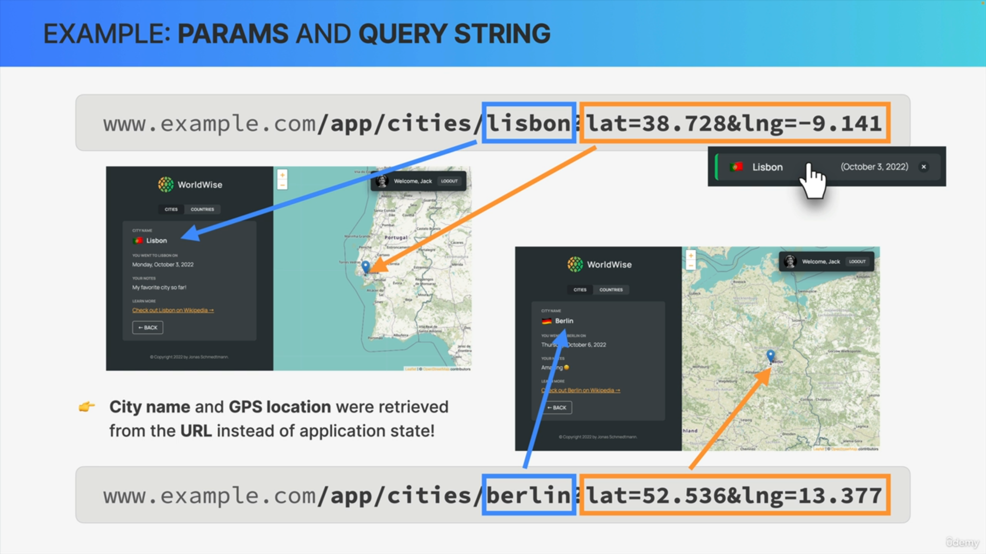

**Summary**

Storing state in the URL using React Router enhances global accessibility, ease of data transfer, and the ability to share and bookmark specific UI states. This is achieved through path parameters for passing data to specific pages and query strings for storing global state, ultimately leading to a better user experience and more efficient state management.